|  |  |
| --- | --- |
| Date | 28 June 2025 |
| Team ID | LTVIP2025TMID50890 |
| Project Name | Comprehensive Analysis and Dietary Strategies with Tableau: A College Food Choices Case Study |
| Maximum Marks | 4 Marks |

**2. Empathy Map**

Understanding the users — *college students* — is essential to designing meaningful visual analytics. The empathy map below represents a structured understanding of their thoughts, feelings, behaviors, and pain points, which inform how the data should be visualized and interpreted.

**2.1 Target Persona**

| **Attribute** | **Description** |
| --- | --- |
| **User Type** | Undergraduate and graduate college students |
| **Age Group** | 18 – 25 years |
| **Location** | Primarily living on-campus or off-campus in urban college areas |
| **Lifestyle Factors** | Busy schedules, budget constraints, frequent exams, exposure to fast food |
| **Health Consciousness** | Moderate to low awareness of nutritional content in daily meals |

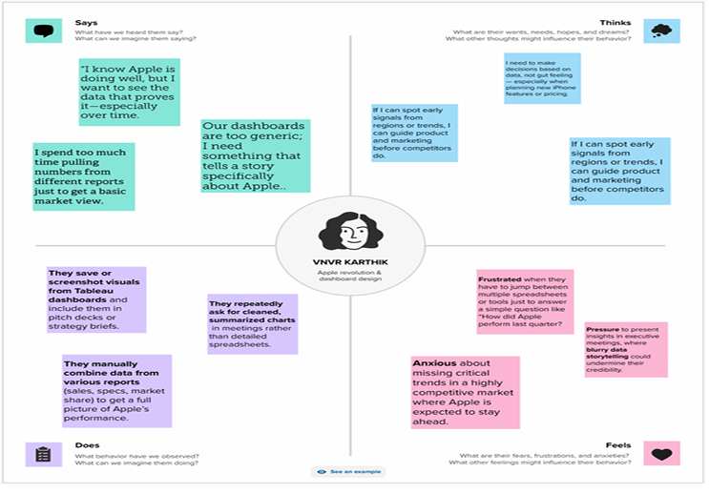

**2.2 Empathy Map Table**

|  |
| --- |
| - Unhealthy food readily available  - Peers with similar poor food habits  - Limited awareness campaigns about health and nutrition |

|

| **What they HEAR** | - “It’s okay to skip meals when you're busy.”  
- “Junk food is cheap and convenient.”  
- “Healthy food is expensive.”  
- Health advice from family, friends, social media influencers |  
| **What they THINK & FEEL**| - “I want to eat healthier but it’s too hard.”  
- Guilt after overeating or skipping meals  
- Anxiety about weight and health  
- A desire for personalized and easy-to-follow nutrition guidance |  
| **What they SAY & DO** | - “I don’t have time to cook.”  
- Frequently order takeout or eat in campus cafes  
- Rarely read food labels  
- Share meal photos on social media |

**2.3 Pain Points and Gains**

| **Pain Points (Challenges)** | **Gains (Goals & Motivations)** |
| --- | --- |
| ❌ Lack of time and motivation to cook or plan meals | ✅ Want to improve health and focus |
| ❌ Limited awareness about nutritional content | ✅ Prefer personalized nutrition plans |
| ❌ High cost of healthy food options | ✅ Want affordable, healthy food alternatives |
| ❌ Irregular eating patterns due to classes, work, and social commitments | ✅ Seek visual guidance and data-driven tips to form better habits |
| ❌ Poor cafeteria options and fast food dependency | ✅ Want quick insights into their diet to take corrective steps |

**2.4 Empathy Insights Summary**

By diving into the students’ perspectives, we discovered a significant **gap between intent and behavior**. Students want to eat better and live healthier lives, but lack of information, time, and affordability become major barriers. This empathy-driven understanding allowed us to design **data visualizations in Tableau that are intuitive, personalized, and directly actionable** — not just technical, but human-centered.